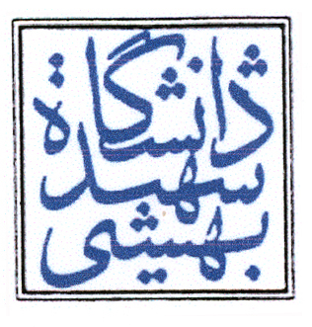

Abstract :

Key Words :
Shahid Beheshti University & Iranology Foundation

Author:
Title:
Supervisor: Adviser :
M.ac Degree in Iranology:
Graduation date :
Key Words :

